Lab 1 – HTML5

- Write a simple poem and represent it as a web page. Give a title for the poem.
Make rhyming words in the poem as bold.

<!DOCTYPE html>
<html lang="en">
<head>
<meta charset="UTF-8">
<meta name="viewport" content="width=device-width, initial-scale=1.0">
<title>The Joy of Spring</title>
</head>
<body style="text-align: center;">
<h1>🌈 The Joy of Spring 🌈</h1>
<p>
The sun is out, the sky is <strong>blue</strong>,<br>
The flowers bloom in every <strong>hue</strong>.<br>
Birds are singing in the <strong>air</strong>,<br>
A joyful song beyond <strong>compare</strong>.<br>
The breeze is soft, the world is <strong>bright</strong>,<br>
All is peaceful, all is <strong>right</strong>.<br>
<br>🌷🌷🌷🌷🌷🌷🌷🌷🌷🌷🌷🌷🌷🌷🌷🌷🌷🌷🌷🌷🌷🌷🌷🌷🌷🌷🌷
</p>
</body>
</html>

Output -
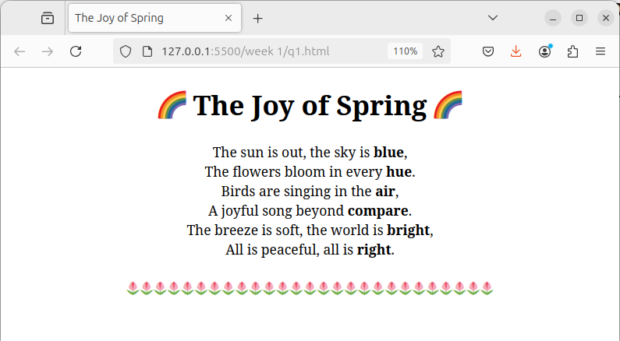
2. Assume you have brought a new car. Write down the list of additional accessories you need for the car as an unordered list in HTML. Also, list the travel plans on the car as an ordered list.

<!DOCTYPE html>
<html lang="en">
<head>
<meta charset="UTF-8">
<meta name="viewport" content="width=device-width, initial-scale=1.0">
<title>Car Accessories and Travel Plans</title>
</head>
<body style="text-align: center;">
<h1>Car Accessories and Travel Plans 🚗</h1>
<h2>Essential Accessories for My New Car:</h2>
<ul style="display: inline-block; text-align: left;">
<li>Seat covers</li>
<li>Car floor mats</li>
<li>Portable car vacuum cleaner</li>
<li>Sunshades</li>
</ul>
<h2>Travel Plans in My New Car:</h2>
<ol style="display: inline-block; text-align: left;">
<li>Weekend getaway to the mountains</li>
<li>Road trip along the coast</li>
<li>Family road trip to a theme park</li>
</ol>
</body>
</html>

Output -

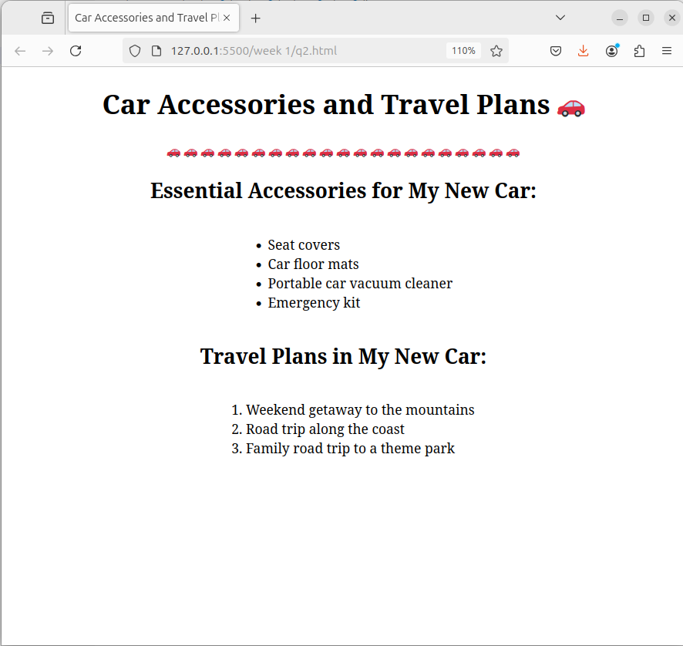

3. Complete the following website name “Share your Winter Vacation Videos”. The required video files are located inside the compressed folder “Week 1 Assignment Files/Media/”.

<!DOCTYPE html>
<html lang="en">
<head>
<meta charset="UTF-8">
<meta name="viewport" content="width=device-width, initial-scale=1.0">
<title>Share Your Winter Vacation Videos</title>
<style>
body {
font-family: Arial, sans-serif;
text-align: center;
margin: 0;
padding: 0;
}
h1 {
margin: 20px 0;
font-size: 2.5rem;
color: #333;
letter-spacing: 1px;
}
.videos-container {
display: flex;
justify-content: center;
align-items: flex-start;
gap: 30px;
padding: 20px;
margin: 0 auto;
flex-wrap: wrap;
max-width: 1200px;
}
figure {
width: 300px;
text-align: center;
border-radius: 10px;
overflow: hidden;
background: #fff;
box-shadow: 0 4px 12px rgba(0, 0, 0, 0.1);
transition: transform 0.3s, box-shadow 0.3s;
}
figure:hover {
transform: translateY(-5px);
box-shadow: 0 8px 16px rgba(0, 0, 0, 0.2);
}
video {
width: 100%;
height: auto;
border-bottom: 1px solid #eee;
}
figcaption {
padding: 15px 10px;
font-size: 1.1rem;
color: #555;
background: #fafafa;
}
</style>
</head>
<body>
<h1>Share Your Winter Vacation Videos</h1>
<div class="videos-container">
<figure>
<video controls>
<source src="vid1.mp4" type="video/mp4">
Your browser does not support the video tag.
</video>
<figcaption>Paris</figcaption>
</figure>
<figure>
<video controls>
<source src="vid2.mp4" type="video/mp4">
Your browser does not support the video tag.
</video>
<figcaption>Venice</figcaption>
</figure>
<figure>
<video controls>
<source src="vid3.mp4" type="video/mp4">
Your browser does not support the video tag.
</video>
<figcaption>Lake View</figcaption>
</figure>
</div>
</body>
</html>

Output -

